Multiple-choice section – choose the correct answer

Question 1 [5.1]

A square has side length 6 cm. What is its perimeter?

A 6 cm B 24 cm C 12 cm D 36 cm

Question 2 [5.3]

A circle of radius 10 cm has a circumference correct to 2 decimal places of:

A 62.83 cm B 31.41 cm C 62.84 cm D 31.42 cm

Question 3 [5.4]

A parallelogram of area 24 cm2 and height 12 cm has a base length of:

A 2 cm B 4 cm C 8 cm D 6 cm

Question 4 [5.6]

The total area of a shape formed by joining a 9 cm square to a 12 cm square is:

A 81 cm2 B 144 cm2 C 441 cm2 D 225 cm2

Question 5 [5.4]

$\sqrt{144}-3^{2}×(1-3)$ What is the area of the triangle in square centimetres?

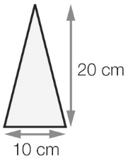

A 200 B 100 C 50 D 30

Question 6 [5.7]

The volume of a rectangular prism with height 2 cm, width 3 cm and length 4 cm is:

A 8 cm3 B 16 cm3 C 24 cm3 D 48 cm3

Question 7 [5.7]

When a cube with edge length 10 cm is filled with water it will hold:

A 1 L B 2 L C 10 L D 40 L

Question 8 [5.8]

The date and time 5 hours and 30 minutes after 11:30 pm on 6 September is:

A 7 September 4:30 am B 7 September 4 am C 7 September 5:30 am D 7 September 5 am

Question 9 [5.8]

Alana started a marathon at 10:45 am and finished at 3:05 pm. The time that she took was:

A 4 hours 20 minutes B 4 hours 50 minutes C 4 hours 40 minutes D 3 hours 20 minutes

Question 10 [5.7]

What is 2000 cm3 converted to litres?

A 20 L B 2 L C 0.2 L D 200 L

Multiple-choice results: ___ / 10

Short answer section

Question 11 4 marks [5.1, 5.4]

Find the perimeter and area of a rectangle with length 12 cm and width 10 cm.

Question 12 2 marks [5.1]

Find the perimeter of the rectangle.

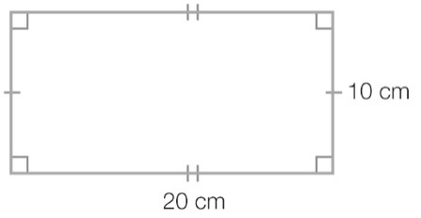

Question 13 2 marks [5.1]

Find the perimeter of the shape.

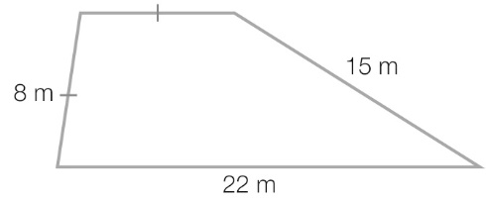

Question 14 2 marks [5.1]

Find the perimeter of a regular hexagon with edge length 5 cm.

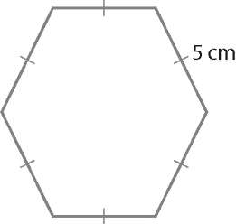

Question 15 4 marks [5.1]

Find the perimeter of each shape.

(a)  
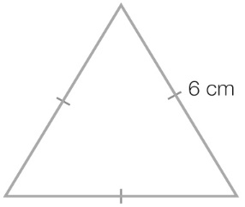

(b)

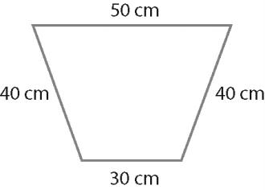

Question 16 2 marks [5.4]

Find the area of the kite.

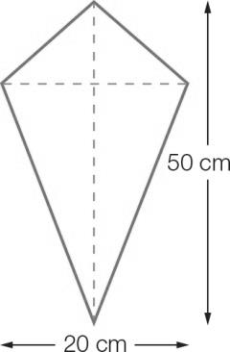

Question 17 4 marks [5.3]

Find the circumference of each circle to the nearest centimetre.

(a)

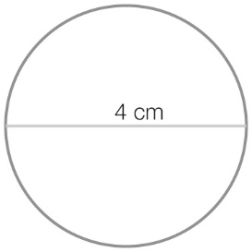

(b)

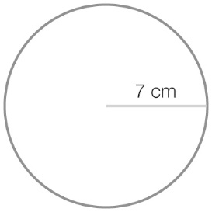

Question 18 2 marks [5.4]

Find the area of a parallelogram that has a base length of 20 cm and a height of 10 cm.

Question 19 2 marks [5.4]

Find the area of the trapezium.

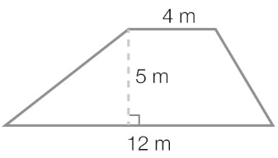

Question 20 4 marks [5.4]

Find the area of the following shapes.

(a)

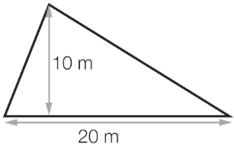

(b)

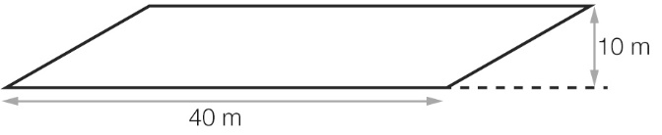

Question 21 2 marks [5.5]

Find the area of the circle correct to 2 decimal places.

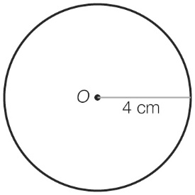

Question 22 2 marks [5.5]

Find the area of the shape correct to 2 decimal places.

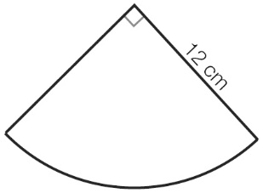

Question 23 2 marks [5.6]

Find the area of this figure.

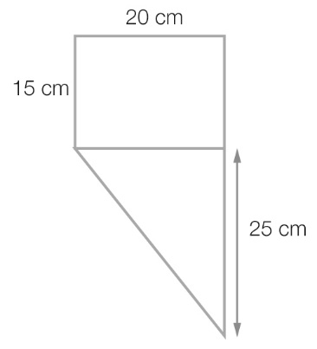

Question 24 2 marks [5.6]

Find the area of this figure.

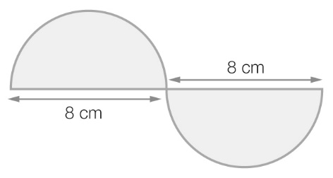

Question 25 2 marks [5.7]

Calculate the volume of the cylinder, correct to 1 decimal place.

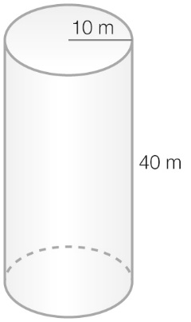

Question 26 2 marks [5.7]

Calculate the volume of the triangular prism.

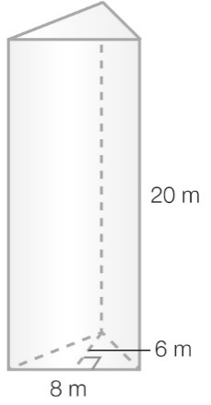

Question 27 4 marks [5.7]

(a) Find the volume of this fish tank.

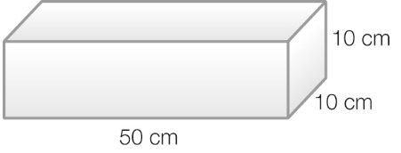

(b) How many millilitres of water is needed to fill the fish tank?

Question 28 3 marks [5.8]

Imogen arrived at school at 8:30 am after taking a 15-minute tram ride from home. The first lesson started 10 minutes after she arrived at school. Recess, following the first three lessons, was 120 minutes later. Recess lasted 30 minutes. Two lessons, each of length 50 minutes, followed recess and then it was lunch time. Use the information to find:

(a) the time that Imogen caught the tram to get to school

(b) the time that recess started

(c) the time that lunch started.

Question 29 3 marks [5.8]

What time is it 4 hours after:

(a) 6:50 am

(b) 10:15 am

(c) 5:20 pm

Short answer results: ___ / 50

Extended answer section

Question 30 4 marks [5.3, 5.5]

Alec is baking a cake. He is using a 15 cm round cake tin.

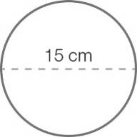

(a) What is the circumference of the cake? Give your answer to 2 decimal places.

(b) What is the area of the top of the cake? Give your answer to 2 decimal places.

Question 31 4 marks [5.6]

The design for a badge is shown below.

Area of parallelogram = base × height

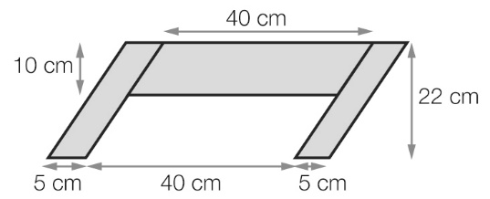

The design is made up of three grey parallelograms and one white parallelogram.

(a) What area of material is needed to make the grey part of the badge?

(b) What area of material is needed to make the white part of the badge?

Question 32 8 marks [5.5]

A dartboard is shown below. The circles are of radius 1 cm, 2 cm, 3 cm, 4 cm and 5 cm.   
The areas labelled *A*, *B*, *C*, *D* and *E* are rings; they do not overlap.

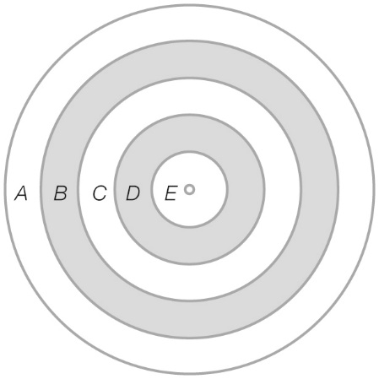

(a) Find the area for each of the following rings.

(i) *E* (ii) *D* (iii) *A*

(b) How many times bigger is the area of the whole dartboard compared to circle *E*?

Question 33 6 marks [5.6]

In the equilateral triangle below there are three billiard balls which just touch each other and the inside of the triangle. The radius of each billiard ball is 5 cm. The sides of the equilateral triangle are   
15 cm long and its height is 24 cm.

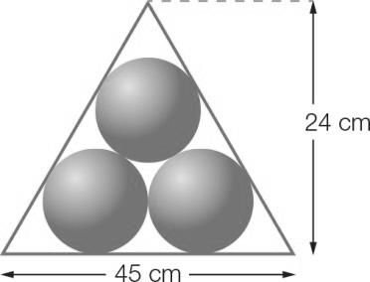

Find:

(a) the area of the triangle

(b) the area taken up by the three billiard balls

(c) the area of the triangle not used by the billiard balls

Question 34 4 marks [5.7]

The diagram shows a model of a spa tub.

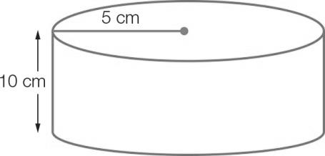

(a) Find the volume of the model tub.

(b) How many litres of water can the tub hold?

Extended answer results: ___ / 26

TOTAL test results: ___ / 86